COUNTY OF OAKLAND
OFFICE OF THE SHERIFF
MICHAEL J. BOUCHARD


Date: / /

Sheriff Cadet I Application

(UNPAID POSTION)

Applicant’s Name:
Last First Middle

Street Address:

City: State: ZIP:

Previous Address:

City: State: ZIP:

Telephone: Home: Cell: Business:

Email Address:

Male
Female Date of Birth: / /
Age:

Driver’s License #:

Current School Name and Location Grade/Graduated Grade Point

Previous High School you attended:

School Name and Location Grade Point

Do you speak any other language besides English? If yes, please list the
language(s)

List of all social media sites and usernames:

.

Page 1

Have you ever been convicted of or charged with a violation of the law? Yes No

If yes – was it a Felony?_
___
_ Misdemeanor?_
_Traffic Violation?_
_City Violation?_ _

If you answered yes to any of the above, please indicated the nature of the crime or violation and the outcome:
___
___
___

Are you employed? Yes No

If yes, list your Employment History, starting with the most recent:

Business: Phone: ( ) _ Address:
Dates Employed: to Hours per week

Supervisor Name and Title

End Date: Reason for leaving:

Business: Phone: ( ) _ Address:
Dates Employed: to Hours per week

Supervisor Name and Title

End Date: Reason for leaving:

Mother’s Name

Mother’s Street Address:

City: State: ZIP:

Telephone: Home ( )_ Cell ( ) Business: ( )

Mother’s Place of Employment

Employment Address:

Father’s Name

Father’s Street Address:_

City: State: ZIP:

Telephone: Home ( )_ Cell ( ) Business: ( )

Father’s Place of Employment

Employment Address:

Background Information Section

The following information will be used for background investigation. The persons you list as references may be contacted.

List Three Adult References:

Name: Telephone: ( )

Address: Relationship:

Name: Telephone: ( )

Address: Relationship:

Name: Telephone: ( )

Address: Relationship:

List Three Young People You Associate With:

Name: Telephone: ( )

Name: Telephone: ( )

Name: Telephone: ( )

I affirm that all information given, to the best of my knowledge, is true and complete. I understand that giving false information can be case for release from the Cadet Unit, and I may face civil or criminal penalties. My signature authorizes the Oakland County Sheriff’s Office to conduct a criminal history check for the purpose of determining my suitability for admittance to the Cadet Unit.

By signing application I acknowledge that I am aware of Sheriff Cadet I requirements below, and that I could be removed from the Cadet Unit for violation of Sheriff Cadet rules including those related to the position requirement.

Signed: Date: / /

If you are under the age of 18 you will need to have your parent or guardian sign below:

I understand that my; child, whose name appears on the front of this application, wishes to be considered for the position of Sheriff Cadet I in the Oakland County Sheriff’s Office Cadet Unit. I will support my child’s involvement in the Cadet Unit, and will allow my child to attend as many functions as possible. I also understand that my signature authorizes the Oakland County Sheriff’s Office to conduct a criminal history check on my child for the purpose of determining suitability for admittance to the Cadet Unit.

Signed: Date: / /

This application will be kept confidential, and will only be shared with authorized personnel within the Oakland County Sheriff’s Office. The Oakland County Sheriff’s Office reserve the right to deny entry for failing to meet the below requirements, or any other just cause.

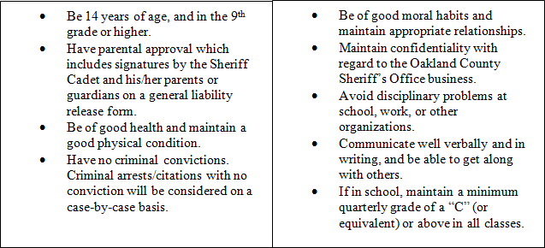To participate in the Oakland County Sheriff’s Office Cadet Unit, you must:
Be at least 16 years of age and be no older than 21.
IF AT ANY TIME THIS INFORMATION CHANGES IT IS THE APPLICANTS RESPONSIBILITY TO NOTIFY THE SHERIFF’S OFFICE

Please email completed applications to Sergeant Behrend:behrendb@oakgov.com

Updated: 02/27/18
Page 4

